**Experiment No 3**

**Aim:** To Study & Verify Half and Full Subtractor.

**Theory :**

Subtractor circuits take two binary numbers as input and subtract one binary number input from the other binary number input. Similar to adders, it gives out two outputs, difference and borrow (carry-in the case of Adder). There are two types of subtractors.

1. Half Subtractor
2. Full Subtractor

**Half Subtractor:**

The half-subtractor is a combinational circuit which is used to perform subtraction of two bits. It has two inputs, A (minuend) and B (subtrahend) and two outputs Difference and Borrow. The logic symbol and truth table are shown below.

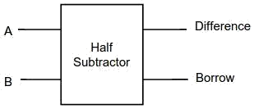

Logic Symbol of Half subtractor

**Truth Table:**

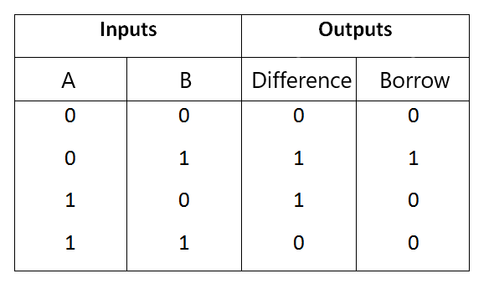

From the above truth table we can find the boolean expression.

Difference = A ⊕ B

Borrow = A' B

From the equation we can draw the half-subtractor circuit as shown in the figure.

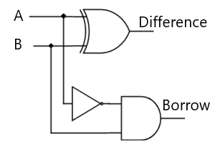

Circuit Diagram of Half subtractor

**Full Subtractor :**

A full subtractor is a combinational circuit that performs subtraction involving three bits, namely A (minuend), B (subtrahend), and Bin (borrow-in) . It accepts three inputs: A (minuend), B (subtrahend) and a Bin (borrow bit) and it produces two outputs: D (difference) and Bout (borrow out). The logic symbol and truth table are shown below.

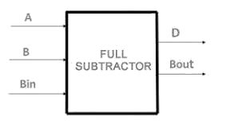

Logic Symbol of Full subtractor

**Truth Table:**

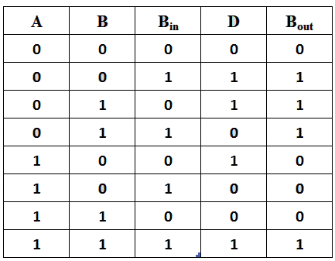

Truth Table of Full subtractor

From the above truth table we can find the boolean expression.

D = A ⊕ B ⊕ Bin

Bout = A' Bin + A' B + B Bin

From the equation we can draw the Full-subtractor circuit as shown in the figure.

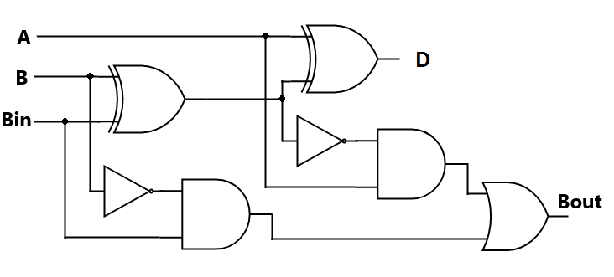

Circuit Diagram of Full subtractor

**Result :** Hence the study of half and full subtractor is completed.